Ethan Allen Peach Skin Sofa

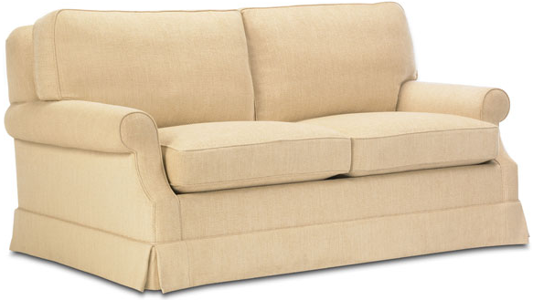

|  |
| --- |
| **DESCRIPTION** |
| Peach Skin Sofa produced by Ethan Allen Co, presents a hand stitched very comfortable affordable sofa. The extra hanging feet sheet makes it easy to change the skins of the sofa without tearing the stitches which is by the way hidden by long hanging feet, long legs hidden by the hang makes the sofa stable and makes it easy to clean underneath. Thick form enables the sofa to stay tagged together. |

|  |  |  |
| --- | --- | --- |
| **Price** | **1595$** | |
| **Dimensions** | **H** x **W** x **L** | **37in x 33in x 54in** |
| **Features** | **High-tech cushion technology with embedded chromium springs makes the form flexible and durable enough to keep things intact.** | |
| **Finished** | **Warm Woolen Cloth** | |
| **Available in** | **Multi Coloured Seating Cloth** | |